Project Report

RAILWAY RESERVATION SYSTEM

A UML PROJECT REPORT

Submitted by PRASANTH SAI [RA2111028010142]
NAGA SAI CHARAN[RA2111028010183]

Under the guidanceof
Professor Angayarkarnni S A
In partial fulfillment for the award of the degree of

BACHELOR OF TECHNOLOGY
In
COMPUTER SCIENCEENGINEERING
With specialization in Artificial Intelligence& Machine Learning
Of

FACULTY OF ENGINEERING AND TECHNOLOGY
S.R.M. Nagar, Kattankulathur, Kancheepuram District

SRM UNIVERSITY
(Under Section 3 of UGC Act, 1956)

BONAFIDE CERTIFICATE

Certified that this project report titled “RAILWAY RESERVATION SYSTEM” is the bonafide work of “PRASANTH SAI [RA2111028010142] & NAGA SAI CHARAN
[RA2111028010183]” who carried out the UML project work under our supervision. Certified further, that to the best of our knowledge the work reported herein does not form any other project report or dissertation based on which a degree or award was conferred on an earlier occasion on this or any other candidate.

SIGNATURE SIGNATURE
Professor ………
GUIDE HEAD OF THE DEPARTMENT

Signature of Internal Examiner Signature of External Examiner

ABSTRACT

A railway reservation system is software that handles distribution, pricing, scheduling, and other railway operations. Most providers have some of these functions digitized, but as we mentioned, this is done sporadically.
One of the largest problems of legacy reservation systems is complicated ticket distribution or even a lack of it in some of its forms. Railways can distribute train seats directly and indirectly. Direct channels include:

- an eCommerce website/app,
- a kiosk or a ticket machine at the railway station,
- on-board point-of-sale devices. Indirect sales come from:
- traditional travel agencies,
- online travel agencies,
- travel management companies,
- traditional ticket booth at the railway station.
Each of these methods requires a different implementation approach.

ACKNOWLEDGEMENT

We would like to express our deepest gratitude to our guide, Angayarkanni S A for her valuable guidance, consistent encouragement, personal caring, timely help and providing me and my team with an excellent atmosphere for doing mini project. All through the work, in spite of her busy schedule, she has extended cheerful and cordial support to us for completing this uml project work.

PROBLEM DESCRIPTION:

“RAILWAY RESERVATION SYSTEM”
Aim: -
The aim of this project is to build an railway reservation system that will completely automate the process of booking a ticket for a train. The system will handle all the booking processes.

Objective: -
The system will be web based and will have two implementations i.e., client side (traveller) and server side (railway). The server-side implementation can only be accessed over the railway internet while the client side can be accessed over the internet. The process begins when prospective traveller wish to book a ticket. If they express interest in any train they will be required to visit the login page and can create a user account at the login page. This is the only part of the system where every user has to have human interaction, this is intended as a security measure to prevent the creation of false user IDs. After verification of any nationally approved photo ID proof a user account will be created and a scanned copy of the ID proof will be uploaded into the profile. After this the user can upload all necessary documents on the portal from the convenience of their home. The system will automatically validate all the documents and the prospective traveller will be able to schedule a date after successful validation.After validation the user can book the ticket through his credentials.
The ticket will be booked and will be immediately published. After booking the ticket the user will be able to make the first payment via internet banking,upi,credit or debit card etc through the system, following which the system will assign the user a unique pnr number and register them as a traveller of that particular train. This system will automatically update the traveller details into the railway webpage database.

Existing System: -
The existing system of registration requires many documents and application forms to be filled out. Data has to be repeatedly entered at each stage of the process and multiple files are made for each user. Documents are verified with multiple copies made for record.The amount of data processing required for each stage of the process ensures that the process of new traveller takes a long time.

Proposed System: -
The proposed system will eliminate the paper trail required for the completion of various formalities. The entire process of prospective ticket booking till user registration can be handled by this system. The booking process can be done entirely on the system and results can be shared. The presence of this system will remove ambiguity in the process that can confuse tense prospective travellers.

Software Requirements: -
- Windows XP
- Apache Tomcat Web Server
- Oracle

Technology Used: -
- Java
- J2EE

Hardware Requirements: -
- Hard Disk – 2 GB
- RAM – 1 GB
- Processor – Dual Core or Above
- Mouse
- Keyboard
- Monitor
- Printer

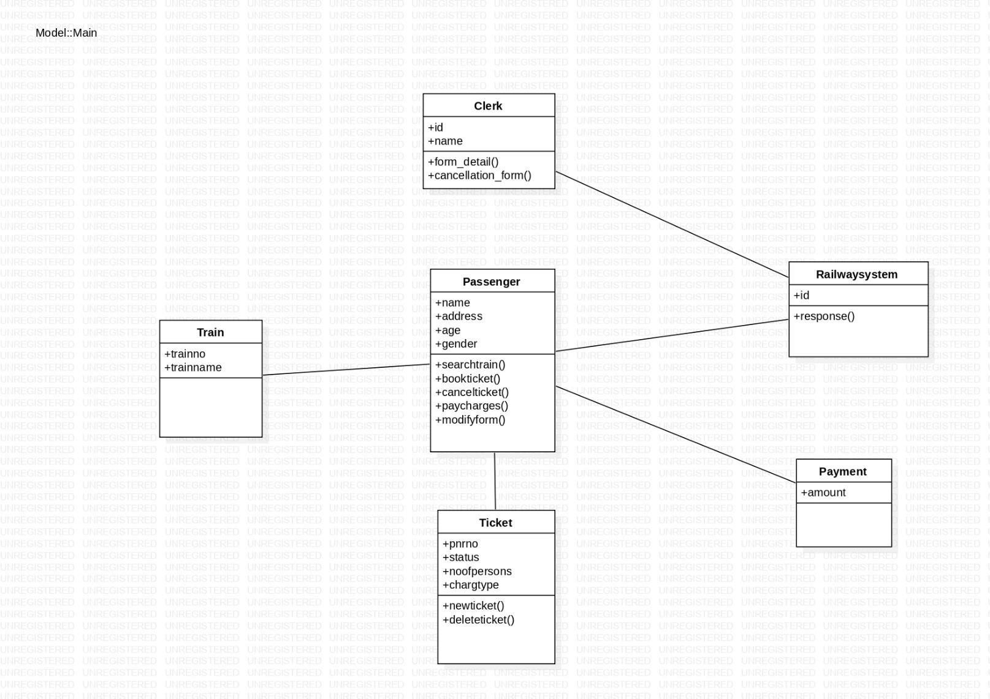

CLASS DIAGRAM

Railway Reservation System Class Diagram describes the structure of a Railway Reservation System classes, their attributes, operations (or methods), and the relationships among objects. The main classes of the Railway Reservation System are Clerk,Train,Passenger,Payment.

The UML Class diagram is a graphical notation used to construct and visualize object-oriented systems. A class diagram describes the structure of a system such as Classes and their attributes, operations (or methods) and the relationships among objects. A class diagram is used to show the existence of classes and their relationships in the logical view of a system.

Basic components: The standard class diagram is composed of three sections: Upper section: Contains the name of the class. This section is always required, to know whether it represents the classifier or an object.
Middle section: Contains the attributes of the class. Use this section to describe the qualities of the class. This is only required when describing a specific instance of a class.
Bottom section: Includes class operations (methods). Displayed in list format, each operation takes up its own line. The operations describe how a class interacts with data.
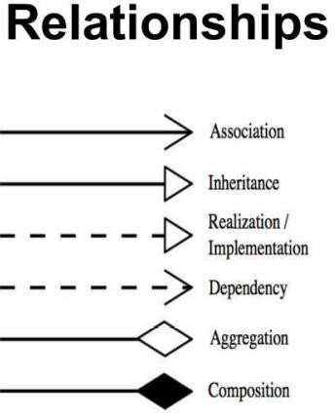

Rules: Class name must be unique to its enclosing namespace. The class name begins in uppercase and the space between multiple words is omitted. The first letter of the attribute and operation names is lowercase with subsequent words starting in uppercase and spaces are omitted. Since the class is the namespace for its attributes and operations an attribute name must be unambiguous in the context of the class. Attribute specification format: visibility attributeName: Type [multiplicity] = DefaultValue {property string}. Operation specification format: visibility operationName (parameterName: Type): ReturnType
{property string}

Classes And Its Attributes:-
- Class Clerk: Attributes-id,name
- Class Train: Attributes-trainno,trainname
- Class Passenger:Attributes-name,address,age,gender
- Class Railway System:Attributes-id
- Class Ticket: Attributes-pnrno,status,noofpersons,chargetype
- Class Payment: Attributes-amount

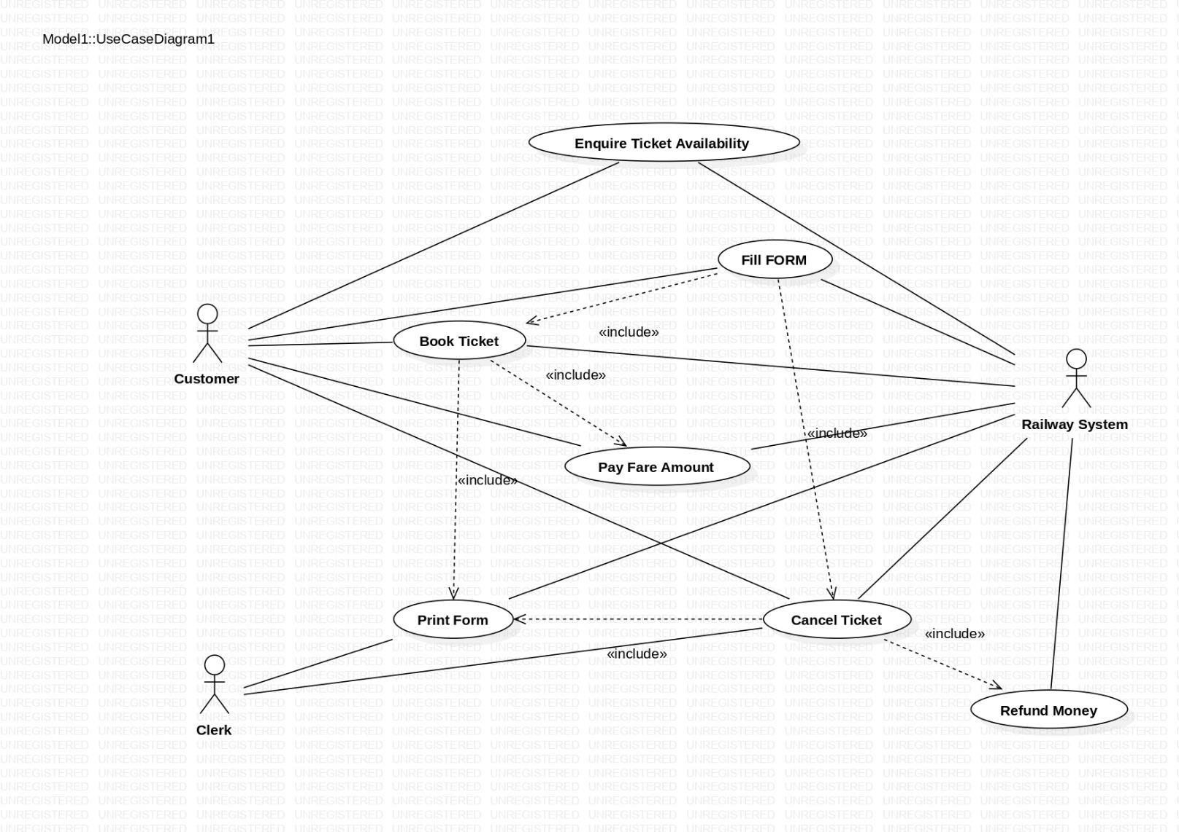
USE CASE DIAGRAM

Use case diagrams are used to depict the context of the system to be built and the functionality provided by that system. They depict who (or what) interacts with the system. They
show what the outside world wants the system to do.

Notation: Actors are entities that interface with the system. They can be people or other systems. Actors, which are external to the system they are using, are depicted as stylized stick figures.

ACTOR:-

- CUSTOMER

- CLERK

- RAILWAY SYSTEM

